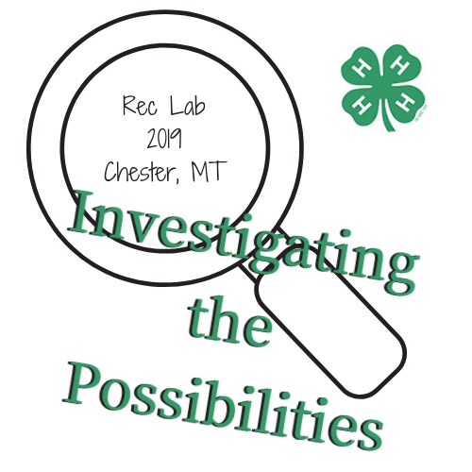
Rec Lab 2019 – Investigating the Possibilities
March 22-24, Chester High School, Chester, MT
There are so many ways you can grow into great leaders and we want you to investigate all of the possibilities! Rec Lab will help you develop your investigative skills, learn how to crack the code of leadership, discover some trade secrets, and be an accomplice to personal development. But well-rounded detectives don’t just help themselves! For our community service project, we would like each district to assemble 50 of the following travel-sized items and bring them to Rec Lab to be assembled into Blessing Bags at Rec Lab to help the less fortunate in our community:
• District 1. – Shampoo & Conditioner
• District 2. - Soap
• District 3. – Comb/hairbrush
• District 4. – Kleenex/Wet Wipes
• District 5. – Hand Sanitizer
• District 6.- Deodorant
• District 7. - Toothbrush
• District 8. – Toothpaste
Youth participants must be 13+ as of October 1, 2018 and adult chaperones must be at least 21 years of age. Registration is $100 and opens January 15 and closes on February 15. If you register after February 15, a late fee of $15 will be added to the registration cost. No registrations will be accepted after March 1.
Participants will be housed at the Chester High School and should bring: sleeping bag, air mattress or sleeping pad, towel and other personal items. If you do not wish to stay at the school, you will be responsible for making your own lodging arrangements at your own cost. Youth must be accompanied by an adult chaperone.

