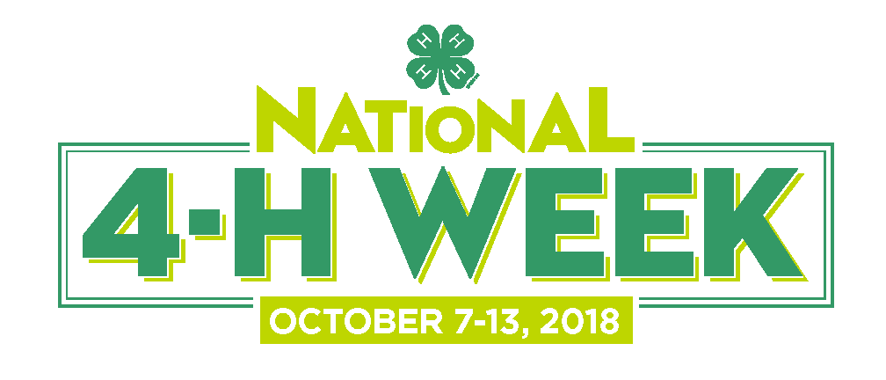
HOW TO WRITE YOUR RADIO PSA

A PSA is a Public Service Announcement. Sometimes they are read by the host on air at a radio station and other times they are pre-recorded to sound like commercials.
Typically organizations like 4-H receive free PSAs when there is a gap to fill on the station's. Follow these steps to write your PSA about National 4-H Week:
1. Leverage the press release for content: Use the same layout as your press release but reduce the copy to one-two paragraphs.
2. Make certain the paragraph still includes all the vital information:
- What is 4-H?
- What is National 4-H Week?
- When does it take place?
- Where will it take place?
- Why does National 4-H Week happen?
- How can I find out more information?
3. Try to include a sentence or two on 4-H and National 4-H Week.
4. Have a "For additional information" sentence to close.
5. Center three number signs (# # #) at the bottom of the page to indicate the end of your press release.

HOW TO GET YOUR PSA ON THE AIR
Follow-up with the radio station is important. After you send out your PSA, you can do an immediate follow-up call to see if it was received. See the document entitled How to Follow-up for more tips on how to conduct your phone calls.
Target your efforts at those radio stations whose audiences are most likely to be interested in 4-H and/or National 4-H Week, and try to customize your PSA to the type of station or listener. For example, you could target children’s stations, educational stations, or rural stations.
Make sure the length of your PSA is 30 seconds or less when read out loud.
###

- SAMPLE RADIO PSA -
FOR IMMEDIATE RELEASE
Contact: Name
Telephone number ◦ e-mail address

PSA for National 4-H Week: October 7 – 13, 2018
National 4-H Week: Inspiring Kids to Do
4-H youth, parents, volunteers and alumni will celebrate National 4-H Week from October 7th through the 13th.

Locally, 4-H [state/county/town) will feature the many ways they inspire kids to do through hands-on-learning experiences.

Also happening in October is 4-H National Youth Science Day, which will kick off on October first. Your child can test their skills in a four-part experience, Code Your World, which will teach them how to apply computer science to the world around them.
Learn more at 4 dash H dot.org

# # #

Tips
Read your PSA out loud. Does it sound like something you would hear on the radio? Is the headline catchy enough to get the attention of the Promotions Director? Listen to the radio personalities in-between songs for this type of event endorsement and try to mirror them in your PSA.
Once your PSA is written, make sure you take the time to edit it carefully! You must be sure that all facts relating to National 4-H Week are correct, that you've provided the correct contact information in your PSA, and that you've answered any questions listeners might have. Be sure to have at least one other person read through your PSA.
FOLLOW-UP! This cannot be skipped. Chances are you’ll need to be persistent to get on air!

