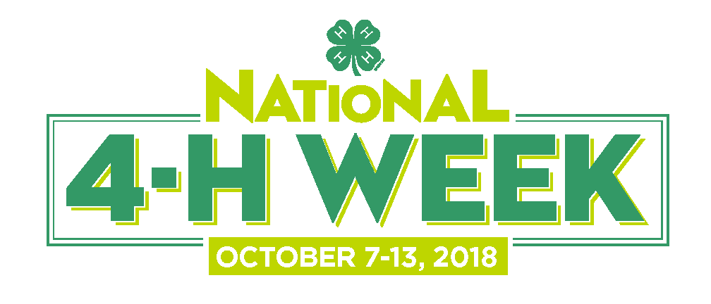

Newsletter Announcement Sample Text (for multiple audiences)

The following examples may be used to target particular audiences. Replace the highlighted text with details specific to your 4-H program and events.
_________________________________
(Audience: Youth)
SHOW YOUR 4-H PRIDE AT NATIONAL 4-H WEEK!
[Town/County/State] (Date, 2018) - Join 4-H'ers around the country to celebrate National 4-H Week from October 7-13 this year!
Every year, National 4-H Week showcases the learn-by doing experiences that 4-H offers young people such as yourself and highlights the remarkable 4-H youth in our community who work each day to make a positive impact on those around them. This year's theme, Inspire Kids to Do, is a campaign that will give kids more opportunities to do, empowering them with the skills they need to succeed in life and career.
Also, in October, 4-H National Youth Science Day will kick off on October 1 and take place throughout the month. This year’s 4-H NYSD challenge is called Code Your World, a computer science-themed challenge co-developed by Google and West Virginia University Extension Service.
2018 is the 11th year of 4-H NYSD, which is expected to reach more than 150,000 kids at thousands of events across all 50 states.
Code Your World is perfect for first-time and beginner coders ranging in age from 8 to 14. It uses games, hands-on fun, and even dancing to teach kids important CS concepts and problem-solving skills.
You can also join us at [Insert information about how your community/town/state is celebrating National 4-H Week]
To find out more about how you can get involved, visit www.4-H.org or call *** on ***.
___________

(Audience: Parents)
SUPPORT 4-H IN YOUR STATE!
[Town/County/State] (Date, 2018) - This fall, families across the country will be coming together to celebrate National 4-H Week, which showcases the learn-by doing experiences that 4-H offers young people and highlights the remarkable 4-H youth in our community who work each day to make a positive impact on those around them.
“The [town/county/state] 4-H family grows every year, giving us additional opportunities to come together and share our experiences and skills. National 4-H Week is a great way to join with the larger 4-H family across the nation to celebrate over a hundred years of empowering youth with the leadership skills they need to succeed in life,” says [LOCAL 4-H SPOKESPERSON WITH UNIVERSITY CREDENTIALS IF APPLICABLE].
This year's theme, Inspire Kids to Do, is a campaign that will give kids more opportunities to do, empowering them with the skills they need to succeed in life and career.
Also in October, 4-H National Youth Science Day will kick off on October 1 and take place throughout the month. The 2018 4-H NYSD challenge, now in its 11th year, is called Code Your World, a computer science-themed challenge co-developed by Google and West Virginia University Extension Service.
Code Your World will teach kids a wide variety of skills in a four-part series that will enable them to apply computer science to the world around them. Developed by Google and West Virginia University Extension Service, this hands-on experience includes a computer-based activity on Google’s CS First platform, as well as three unplugged activities that bring coding to life through games and interaction. Code Your World is perfect for first-time and beginner coders, ages 8 to 14.
You can also join us at [Insert information about how your community/town/state is celebrating National 4-H Week]
To find out more about how you can get involved, visit www.4-H.org or call *** on ***.

_______________

(Audience: Volunteers)

INSPIRE KIDS DURING NATIONAL 4-H WEEK!
[TOWN/COUNTY/STATE] (Date, 2018) - This fall, 4-H youth, parents, alumni and volunteers will come together across the country to celebrate the 76th National 4-H Week, which showcases the learn-by-doing experiences that 4-H offers young people and highlights the remarkable 4-H youth and volunteers in our community who work each day to make a positive impact on those around them.
“The [town/county/state] 4-H family grows every year, giving us additional opportunities to share our experiences and skills. National 4-H Week is a great way for our incredible volunteers to come together with the larger 4-H family across the nation to celebrate over a hundred years of empowering youth with the leadership skills they need to succeed in life,” says [LOCAL 4-H SPOKESPERSON WITH UNIVERSITY CREDENTIALS IF APPLICABLE].
This year's theme, Inspire Kids to Do, is a campaign that will give kids more opportunities to do, empowering them with the skills they need to succeed in life and career.
Also in October, 4-H National Youth Science Day will kick off on October 1 and take place throughout the month. The 2018 4-H NYSD challenge, now in its 11th year, is called Code Your World, a computer science-themed challenge co-developed by Google and West Virginia University Extension Service.
Code Your World will teach kids a wide variety of skills in a four-part series that will enable them to apply computer science to the world around them. This hands-on experience includes a computer-based activity on Google’s CS First platform, as well as three unplugged activities that bring coding to life through games and interaction. Code Your World is perfect for first-time and beginner coders, ages 8 to 14.
You can also join us at [Insert information about how your community/town/state is celebrating National 4-H Week]
To find out more about how you can get involved, visit www.4-H.org or call *** on ***.

_______________________
Short copy
Join us at [ Place ] from [ Date ], where you’ll not only get a chance to catch up with your fellow 4-H’ers and meet new 4-H friends, but you can also [ activity/learning/experience ]! Visit www.4-H.org to find out more.

