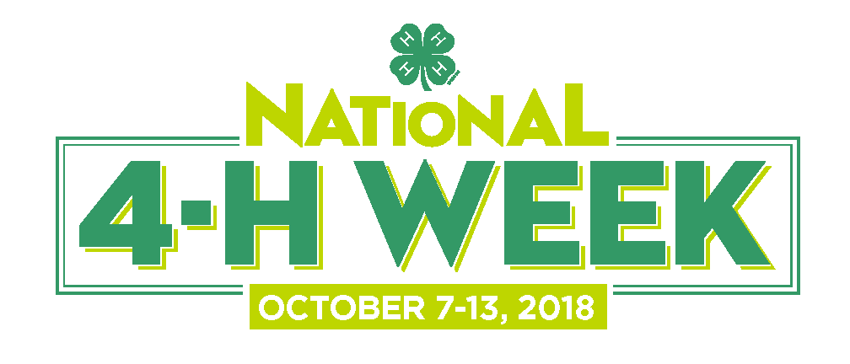
What is a Proclamation?
A proclamation is an official statement or announcement that is usually made by a government official. In America, proclamations are often made by Mayors, Governors, or even the President, yet other state legislators are also able to make proclamations, as can Parks and Recreation departments, school boards and other governing bodies. Proclamations are most often used to:
- announce upcoming events in a city, county or state;
- recognize outstanding achievements of citizens or non-profit organizations such as 4-H;
- make the public aware of an issue; or to
- honor a significant local, state or national occasion.
A proclamation in support of National 4-H Week is a simple yet effective way for your elected officials to endorse the incredible achievements of our 4-H youth and volunteers, and is a great tool to use in your promotion and coverage of any National 4-H Week events.
Requesting a Proclamation
In order to receive a proclamation, you will need to provide evidence that outlines why National 4-H Week deserves the recognition and honor of its own proclamation.
Your first step should be to visit the web-site of the official you would like to approach, for example, go online to see if your Mayor’s office provides any information about the issuance of proclamations in your town or city. Some give detailed information about how to go about requesting a proclamation, and may even provide a recommended template.
If the website doesn’t provide the information you need, your next step should be to call the office and ask for the Communications Director, who will be able to tell you what to include in your request and where to send it. You could also request that the Mayor attend an event that you’re holding as part of National 4-H Week, such as National Youth Science Day. You can ask multiple people for a proclamation, so consider contacting your city council, state legislature, and even your senators.
You can request that 4-H representatives attend the signing of the proclamation, and ask if photos of the signing are allowed. If permission is granted, these can be used in your PR around National 4-H Week.

National 4-H Week Proclamation Template
WHEREAS, 4-H is America’s largest youth development organization, supporting nearly six million youth across the country; and
WHEREAS, 4-H has helped [number] youth in [city/county/state] to become confident, independent, resilient and compassionate leaders; and
WHEREAS, 4-H is delivered by Cooperative Extension – a community of more than 100 public universities across the nation that provides experiences where young people learn-by-doing through hands-on projects in the important areas of health, science, agriculture and civic engagement; and
WHEREAS, National 4-H Week showcases the incredible ways that 4-H inspires kids to do and highlights the remarkable 4-H youth in [city/county/state] who work each day to make a positive impact on those around them; and
WHEREAS, 4-H’s network of nearly 500,000 volunteers and 3,500 professionals provides caring and supportive mentoring to all 4-H’ers, helping them to grow into true leaders, entrepreneurs and visionaries;
NOW, THEREFORE, I, [name, title], do hereby proclaim October 7-13, 2018 as NATIONAL 4-H WEEK throughout [city/county/state] and encourage all of our citizens to recognize 4-H for the significant impact they have made and continue to make by empowering youth with the skills they need to lead for a lifetime.

