Volunteer Recruitment Facebook Posts
The following are examples of Facebook posts that your county can use to target volunteers. You can focus on specific program areas that may need more volunteer support, or make a general call to action.
Right click on the photo and select save as. Save the image to your computer and upload to Facebook when ready to post. Copy the block of text associated with each photo and place into the text area of the Facebook post. Be sure you include some way for them to contact your office, email, website or phone.

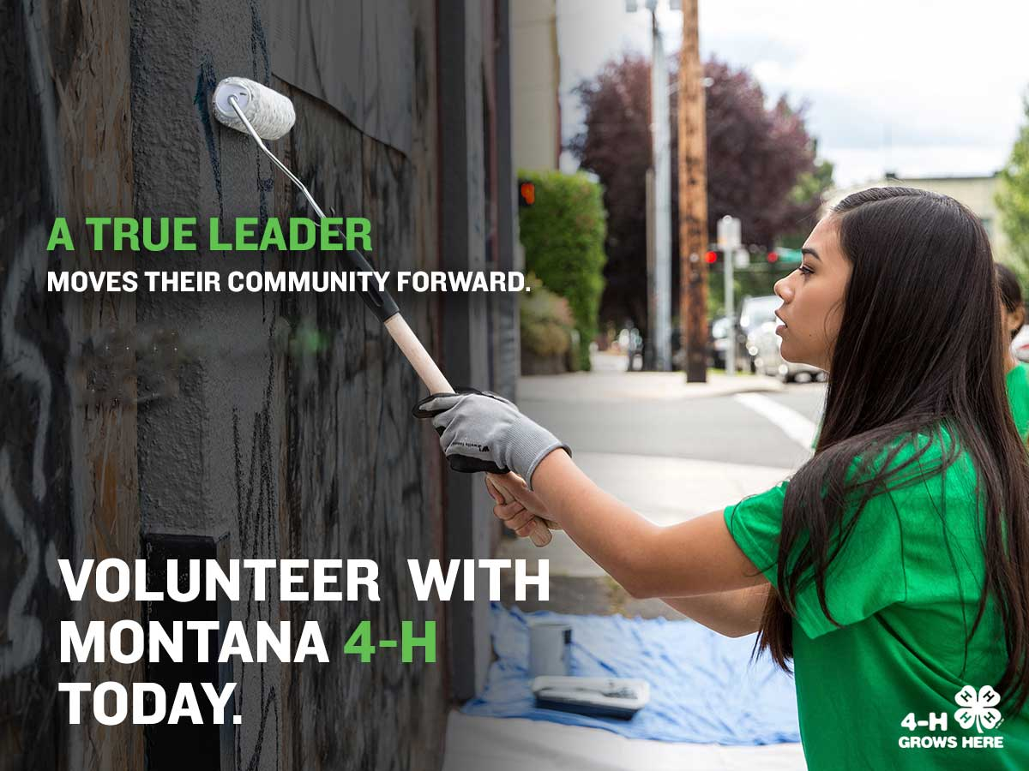
@Montana 4-H has been growing #TrueLeaders for over 100 years. At the core of 4-H are caring adult volunteers just like you. Leave your legacy and pass on your valuable skills and knowledge to a new generation. Learn more about becoming a 4-H volunteer by contacting your county MSU Extension office today! [contact info]

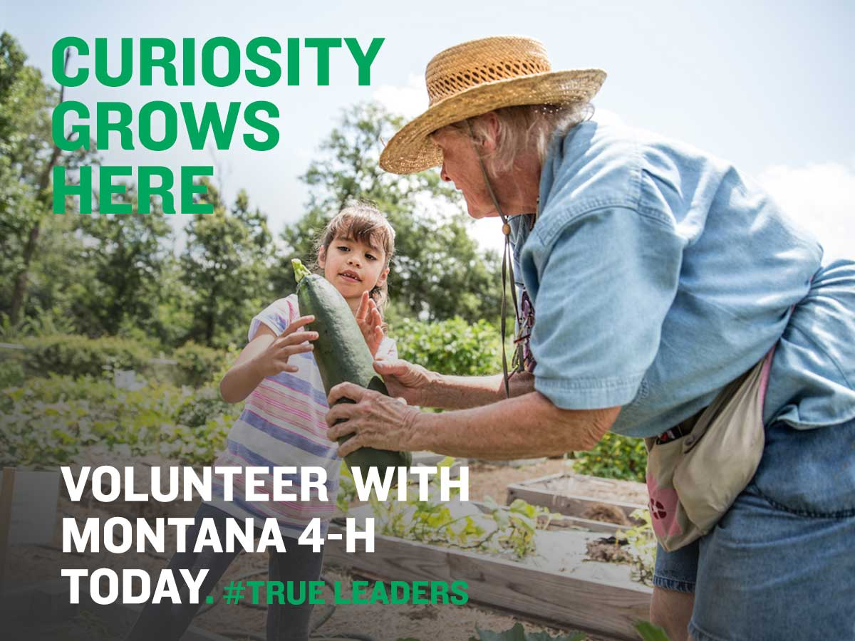
Are you passionate about something? Share your passion and knowledge with a new generation by becoming a 4-H volunteer. There are over 200 different project areas available to Montana 4-Hers, but they need a caring and knowledgeable adult to guide their hand-on learning. Learn more about becoming a 4-H volunteer by contacting your county MSU Extension office today!

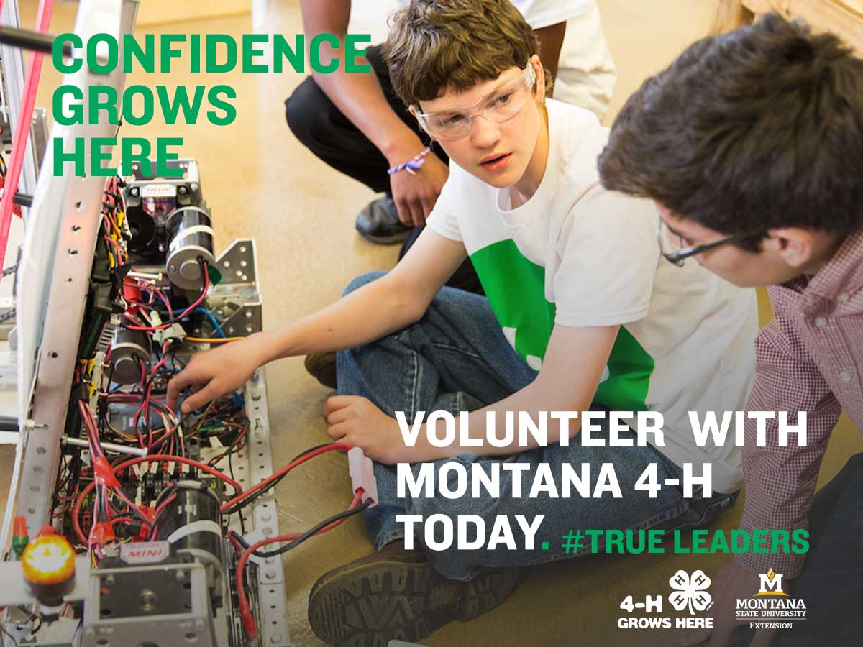
Did you know that hundreds of youth across Montana are exploring the world of robotics and other STEM related fields? If you have experience with science, technology, engineering, or math, consider volunteering with @Montana 4-H and share your skills with a new generation. Learn more about 4-H volunteer opportunities by contacting (insert name) at (phone or email) today!

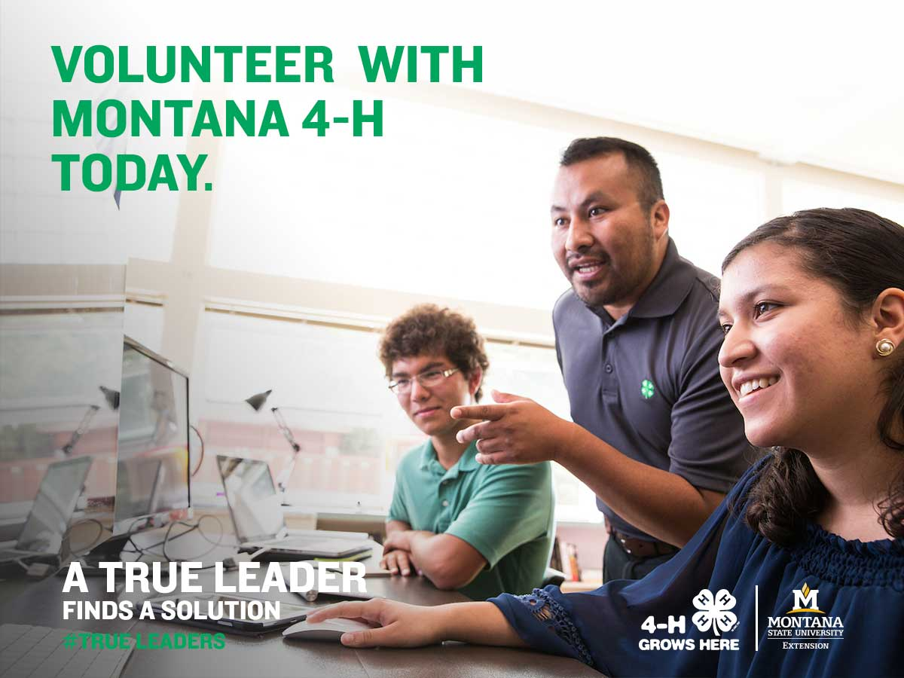
STEM fields are a driving force in today’s world. Help @Montana 4-H youth navigate science and technology projects by giving your time and skills as a #volunteer, and better yourself and your community along the way. Contact your county MSU Extension office today to get started! [email] [phone]

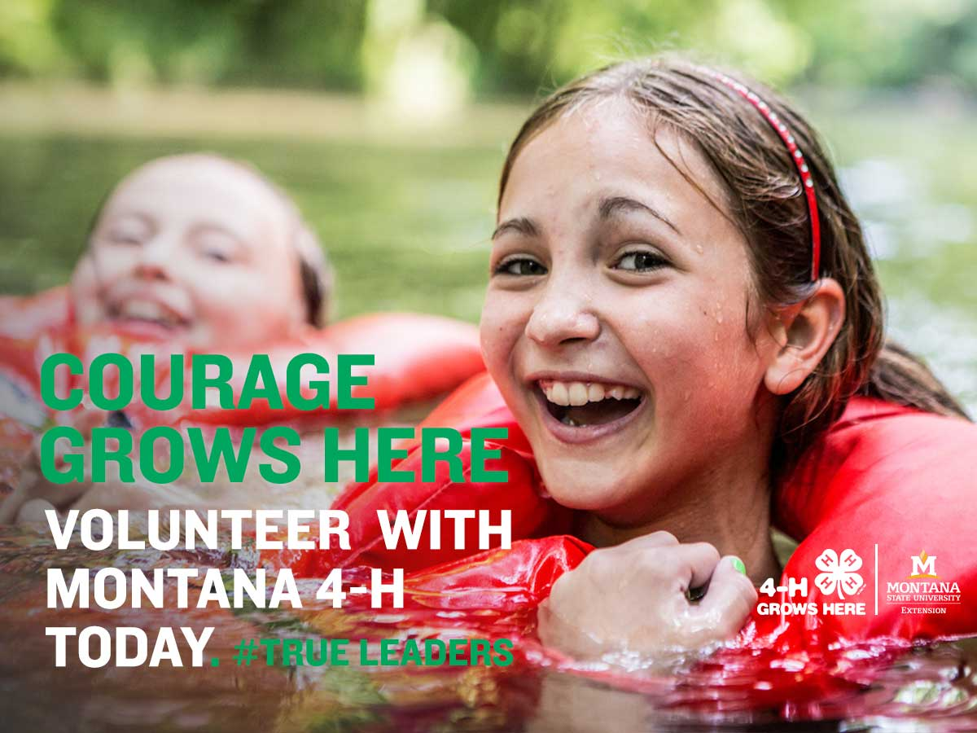
Love the outdoors? Share your passion and skills with 4-H’ers in your community. From Forestry to Outdoor Adventure and Shooting Sports, there is a #volunteer opportunity for you. Help @Montana 4-H expand the horizons of youth by contacting your county MSU Extension office today! [email] [phone]

